An Introduction to Fr. George V. Coyne, S.J.
and the
Polarization of Light

Document Overview:

This is an introduction to the life and career of Fr. George V. Coyne, guest speaker at the 2013 Nobel Conference, The Universe at its Limits, at Gustavus Adolphus College. This document will culminate with a variety of resources to further introduce high school science students to the work of Fr. Coyne and the basics of polarized light.

Minnesota State Academic Science Standards:

Science is a way of knowing about the natural world and is characterized by empirical criteria, logical argument and skeptical review:

9.1.1.1.1 Explain the implications of the assumption that the rules of the universe are the same everywhere and these rules can be discovered by careful and systematic investigation.

9.1.1.1.2 Understand that scientists conduct investigations for a variety of reasons including: to discover new aspects of the natural world, to explain observed phenomena, to test the conclusions of prior investigations, or to test the predictions of current theories.

9.1.1.1.6 Describe how changes in scientific knowledge generally occur in incremental steps that include and build on earlier knowledge.

9.1.1.1.7 Explain how scientific and technological innovations ─as well as new evidence─ can challenge portions of, or entire accepted theories and models including, but not limited to: cell theory, atomic theory, theory of evolution, plate tectonic theory, germ theory of disease, and the big bang theory.

The Universe: The solar system, sun, and Earth formed over billions of years:

9.3.3.2.1 Describe how the solar system formed from a nebular cloud of dust and gas 4.6 billion years ago.

9.3.3.2.3 Compare and contrast the environmental conditions that make life possible on Earth with conditions found on the other planets and moons of our solar system. The big bang theory states that the universe expanded from a hot, dense chaotic mass, after which chemical elements formed and clumped together to eventually form stars and galaxies:

9.3.3.3.1 Explain how evidence, including the Doppler shift of light from distant stars and cosmic background radiation, is used to understand the composition, early history and expansion of the universe.

Type of Activity:

This is a combination of an introductory reading along with a potential for a hands on laboratory to introduce both Fr. Coyne and the science of polarized light. Additionally, there are a couple of links to short YouTube videos to further your knowledge of the work of George Coyne

Duration:

50 – 55 minutes for the combination of reading and laboratory.

Connection to Nobel speakers:

George V. Coyne, S.J. is a Jesuit priest, astronomer, and former director of the Vatican Observatory and head of the observatory’s research group which is based at the University of Arizona in Tucson, Arizona. Since January 2012, he has served as McDevitt Chair of Religious Philosophy at Le Moyne College in Syracuse, NY.

Teacher Tips:

This is initially planned as a Nobel Conference introductory activity in preparation for the presentation of Fr. George V. Coyne, S.J. However, since the concepts of waves, light and the properties of light are basic to the understanding of the universe, we believe this activity could be incorporated at anytime that is convenient to the teacher and their curriculum. This is further enhanced by the streaming and archived videos available at the Gustavus Adolphus website.

An Introduction to Fr. George V. Coyne, S.J.
and the
Polarization of Light

Concepts:
- Big Bang Theory
- Light
- Spectra of light
- Waves of light
- Photons of light
- Polarized light
- Cataclysmic Variables or Interacting Binary Star Systems
- Seyfert Galaxies

Materials:

George V. Coyne, S.J. is a Jesuit priest, astronomer, and former director of the Vatican Observatory and former head of the observatory’s research group which is based at the University of Arizona in Tucson, Arizona. Since January 2012, he has served as McDevitt Chair of Religious Philosophy at Le Moyne College in Syracuse, NY.

Coyne started his academic journey early at the age of 18 when he decided to become a member of the Society of Jesus (S.J.) and pursue the process of becoming a Jesuit priest. Coyne completed his first of many degrees in 1958 when he graduated with a bachelor of science degree in Mathematics and a licentiate in Philosophy from Fordham University in New York City.

He then completed his doctorate degree in Astronomy from Georgetown University in 1962 by performing a spectrophotometric study of the moons surface. Along the way, Coyne has completed research during the years of 1963 to 1965 at Harvard, University of Scranton and the University of Arizona Lunar and Planetary Laboratory. All the while he was working on and completing his priesthood and theological studies at Woodstock College in Woodstock, Maryland and completing that degree in 1965.

Coyne joined the Vatican Observatory as an astronomer in 1969 and became an assistant professor at the University of Arizona’s Lunar and Planetary Laboratory (LPL) in 1970. Over the years at the Vatican Observatory, Coyne studied various deep space objects using polarimetric data and published numerous papers on such objects as Seyfert galaxies, various types of spectral stars and the interstellar medium. In 1978 he was elevated to the Director of the Vatican Observatory and held that position for 34 years before being asked to leave in 2012. He has recently undertaken an interest in cataclysmic variables which consist of two component stars; a white dwarf primary, and a mass transferring secondary star that contributes matter to the smaller and hotter white dwarf. (see figure 1)

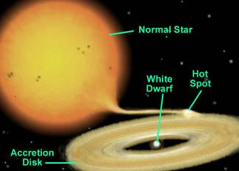
Figure 1 cataclysmic variable stars
http://www.astrosurf.com/vdesnoux/catvar/catvar.html

Coyne has regularly given talks on the strengths and weaknesses of both a fundamental religious belief system as well as scientific endeavors. He clearly has pushed the Jesuit ideal of understanding your faith in Jesus after pursuing a basic understanding of the workings of the universe through empirical, scientific means. He has often pushed the boundaries of what and how we know what we know in both philosophical and scientific circles. We have included several You Tube links to underscore this part of his academic work.

About...
Those Polarizers on Your Face

What you need:

A collection of sunglasses, including at least one pair with polarizing lenses.

Try it and see:

Compare a variety of sunglasses and find out which sunglasses reduce the glare of light reflecting off surfaces. Can you figure out which sunglasses contain polarizing lenses? Look through the sunglasses at a surface reflecting glare and see what happens when you rotate the glasses around. Try to find glare reflecting off a horizontal surface such as a tabletop, water, or a shiny floor, as well as glare from a vertical surface, such as a whiteboard, windows, or other shiny, flat surfaces.

How do the sunglasses (or polarizing filters) have to be oriented to reduce the glare from a horizontal surface? From a vertical surface?

Why does it make sense for the polarizing lenses in sunglasses to be oriented to reduce the glare from horizontal surfaces?

What is going on?

Most light, including that from the sun, from incandescent light bulbs, and from candles, is not polarized. This means that the electrons that wiggle to produce the electromagnetic waves (light) are oscillating in many different planes. To make the light, some electrons might have been vibrating up and down, while others were vibrating from side to side or at any different angle diagonally. Polarized light is produced by electrons that are all vibrating or accelerating in the same plane. Imagine having two people hold the ends of a rope, while one shakes her end from side to side. The wave this would produce in the rope would be horizontally polarized, like the light generated by electrons all wiggling from side to side. If the rope were shaken up and down instead, the resulting wave would be vertically polarized.

Polarized light can be produced from some light sources, but it is more commonly obtained using a polarizing filter (also called a polarizer). Polarizers only transmit light that is oscillating in one plane, called the axis of polarization, while absorbing all other light. If you align two polarizers so their axes of polarization are at right angles to each other, they will not transmit any light.

Polarizing filters are made by uniformly aligning tiny crystals or large polymer molecules that preferentially absorb light oscillating in certain planes.
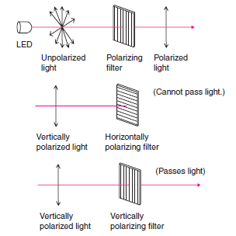

Figure 1: Polarization of light
http://www.ia.omron.com/support/guide/43/principles.html

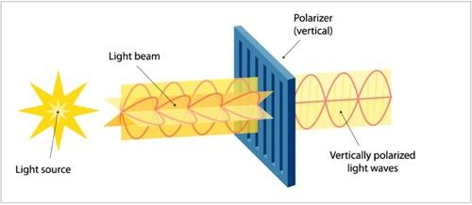
Figure 2: Polarization of Light
www.astro-canada.ca

Light reflected from water, glass, and most other nonmetallic surfaces is polarized. These materials reflect light waves that are vibrating mostly parallel to the material’s surface, while absorbing or refracting light vibrating in other planes.

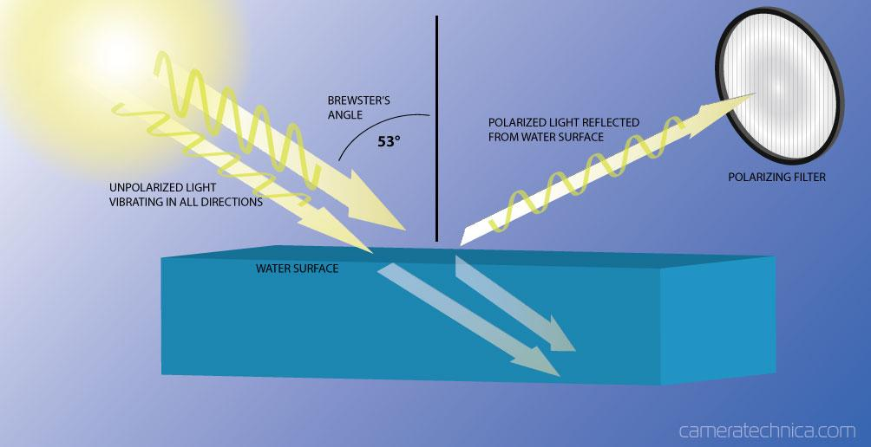

Figure 3: How a polarizing filter works
www.cameratechnica.com

Investigating Materials
With
Polarized Light

What you need:

(It is not necessary to have all of the following items. Rather, it is important to provide a variety of different things for comparison.)

• Several polarizing filters

• An unpolarized white light source, such as an overhead projector, a light table, or an incandescent lamp

• Identical glass jars containing a variety of substances, such as:

• Three different concentrations of corn syrup in water (recommended labeling: full strength, 1/2 dilution, and 1/4 dilution, plus one jar containing an “unknown” dilution)

• Saccharin and water

• Soapy water

• Plain water

• Table sugar and water or glucose (dextrose) and water

• Glass jars of different widths containing solutions of corn syrup at the same concentration

• Chunks of different crystals, such as calcite, mica, tourmaline, herapathite, quartz, table sugar crystals or rock candy, rock salt, etc.

• Clear plastic items that can be flexed or stretched, such as a hard plastic box, a ruler, a sandwich bag, etc.

• Other fun things such as ice cubes, clear unsweetened gelatin (cut in cubes that jiggle), cellophane tape layered on a transparency sheet for different thicknesses, etc.

Where to get all this

Most materials are readily available at a grocery store or general purpose store. Baby food jars work well as identical jars for different solutions. Rocks and minerals can be found at most “nature” stores, including The Nature Company (be sure to ask for their educators’ discount). Polarizing filters can be purchased through Edmund Scientific for approximately $17 per square foot for a large sheet (14”x24”; unit prices go up if you buy smaller pieces).

Setting it up
There are at least two ways to do this activity. One is to use an overhead projector or light table. Place a polarizing filter on the surface of the light table. Place an object of choice on the polarizing filter and look at it through a second polarizing filter. Additionally, you can look through both polarizers(at once) at various objects sitting on the plain overhead projector or light table surface.

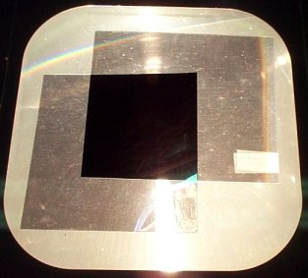

Try it and see
Look through a polarizing filter at several different solutions and materials (see the list of materials above). Compare what happens when polarized light passes through the material to what happens if you use unpolarized light. Find out as much as you can about what happens when polarized light interacts with these different materials. What creates the effects you see is an interesting question, but for this activity, think about how polarization effects can be useful. Make a list of everything you discover about polarized light and what it does. Be as specific as possible in the conclusions you draw from your experiments.

Take a variety of the items listed above in the materials list and play with them using the polarizing filters. Have fun, make observations and fill in the following chart with your observations and thoughts.

We observed: | We concluded:
When looking through a polarizer at a bright light source:

After your observation time, see if you can answer these questions:

Does polarized light produce the same effect when passing through different concentrations of a solution?

Can you figure out the concentration of the unknown corn syrup solution?

Do all solutions turn colors when viewed through a polarizer as polarized light passes through each?

What do the various colors on the plastic items suggest about it’s design or lifespan?

Sources:

The two activities from above have been used and edited from:
http://www.lbl.gov/MicroWorlds/teachers/polarization.pdf

George Coyne biographic information: http://en.wikipedia.org/wiki/George_Coyne

Burnie, David. Eyewitness Science: Light. Dorling Kindersley, Inc., New York, 1992. A strongly
graphical presentation of the physics of light in historical context. Explains concepts and their
development over time in nontechnical terms.

Erhlich, Robert. Turning the World Inside Out and 174 Other Simple Physics Demonstrations.
Princeton University Press, Princeton, 1990. Wide range of experiments covering everything
from optics to magnetism and mechanics. Excellent chart at beginning of the book details cost,
excitement level (really), time and construction commitment for each experiment. Geared to
middle and high school students.

The Exploratorium Science Snackbook. The Exploratorium, 3601 Lyon Street, San Francisco,
California, 94123 (Tel: 800-359-9899 or 415-561-0393), 1991. Lists a dazzling variety of science
demonstrations, with full descriptions of how to make them and brief explanations of what is
going on in each.

Falk, David, Dieter Brill, and David Stork. Seeing the Light: Optics in Nature, Photography,
Color, Vision, and Holography. John Wiley and Sons, New York, 1986. An excellent and
thorough reference source for light, its properties, and how we use it written at the high
school or college level. Lots of good diagrams and pictures.

Gamow, George. Mr. Tompkins in Paperback. (Containing "Mr. Tompkins in Wonderland"
and "Mr. Tompkins Explores the Atom.") Cambridge University Press, New York, 1965. An
excellent, enjoyable presentation of quantum physics in the form of extended metaphors, as
seen through the eyes of the curious everyman, Mr. Tompkins.

Gonick, Larry and Arthur Huffman. The Cartoon Guide to Physics. HarperCollins, New York,
1991. A humorous (and accurate) comic-book approach to basic physics concepts, this book
brings abstractions down to earth. Helpful for beginning students.

Hewitt, Paul G. Conceptual Physics, 7th ed. Scott, Foresman and Company; Glenview, Illinois;
1993. This college physics text (also available in a high-school version) uses mathematics
chiefly as a supplement to accessible, intuitive explanations,
keeping the everyday world at center stage.

Morrison, Philip, Phylis Morrison, and the Office of Charles and Ray Eames. Powers of Ten: A
Book About the Relative Size of Things in the Universe and the Effect of Adding Another Zero.
Scientific American Library, New York, 1982.
Macaulay, David. The Way Things Work. Houghton Mifflin, Boston, 1988. A pictorial book for
a lay audience brimming with details about the machinery of our world.

Nye, Bill. Bill Nye The Science Guy’s Big Blast of Science. Addison-Wesley Publishing
Company, New York, 1993. A fun and slightly irreverent approach to exploring science from “molecules to the Milky Way.” A wide variety of easy-to-do activities and experiments with
explanations that everyone can understand.

YouTube links:

A brief video on the age of the universe:
http://www.youtube.com/watch?v=OwWqrXGtrRs

George Coyne on Science and Religion:
http://vimeo.com/20272373

On-line Print links:

A 2006 article on the Catholic Online website explaining Fr. Coyne’s position on Darwinian Evolution and it’s implications toward catholic doctrine. A good precursor to the next article:
http://www.catholic.org/national/national_story.php?id=18503

An article in the Daily Mail, from August of 2006, on the removal of Fr. Coyne from his position as the Director of the Vatican Observatory:
http://www.dailymail.co.uk/news/article-401950/Pope-sacks-astronomer-evolution-debate.html

